Instructor/Troubleshooting Guide
System Hardware
Why is the screen blank? |   1. Is the Pi plugged in? Check the power cable, and look for a constant red light.  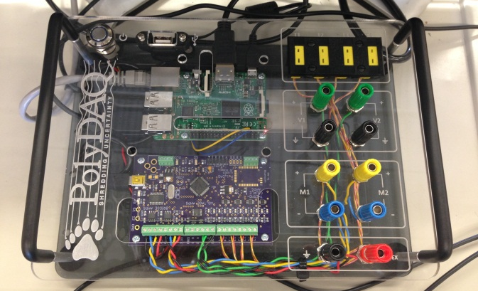  1. Is the Pi on? If so, the blue power light should be on (the yellow light that blinks sporadically indicates network activity).  2. To Power the system on, press power button  on PolyDAQ. (Boots PolyDAQ and the Raspberry Pi).  3. Is the screensaver on? Jiggle the mouse or press the space key.  4. Is the monitor on? Turn the monitor on.  5. Is the video input correct? The Pi is connected to the DIGITAL INPUT.  Press the input button 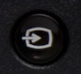 on the monitor and switch it to digital input (DVI).
Is the PolyDAQ on? | 1. Check that the USB power cable that connects the Pi to the PolyDAQ is plugged in.  2. Check the lights: there is a constant green light at the top of the PolyDAQ that is on when it is powered. A second, orange light pulses (we call it the “hearbeat”).
The keyboard/mouse doesn’t work! | 1. You’re using the wrong keyboard/mouse. Use the keyboard and mouse on top of the cart, not the ones on the sliding shelf.  2.Get a new keyboard/mouse.  Instructor/Troubleshooting Guide
The blue power button doesn’t work! | 1. It doesn’t work to power down the system; it only works to power UP. Do a soft shutdown. See the Quick Start Guide for soft shutdown instructions.  2. If the system is locked up and you can’t do a soft shutdown, pull the plug on the system and restart, but ONLY as a last resort!  3. The light might be out. The light is powered by a voltage output on the PolyDAQ. Is the PolyDAQ on? Check the red and black wires that connect the light to the PolyDAQ terminals (they’re connected to channels marked Ground and Vext).
The Pi won’t boot! | Unplug the system and switch out the microSD card with a spare one.
Software
When I Choose Port, no choices come up! I don’t see the /dev/ttyUSB0 option. | 1. Check to see that the PolyDAQ is powered and its heartbeat is on. Check the USB cable that goes from a USB port on the Pi to the power port (a mini USB plug) on PolyDAQ.  2. Reboot the system.
When I Choose Port, I get more than one choice! | There might be a thumb drive connected to the data port on the system. Select /dev/ttyUSB0 for PolyDAQ.
I chose the right port, but the software won’t let me choose channels or anything else! | There may have been an error connecting to the PolyDAQ board. Check the status box at the bottom left of the GUI; if there was a connection error, the status will read ERROR... Click the selection box again, click Choose Port again, and then click /dev/ttyUSB0 again. This should connect the second time.
I’m not getting a correct signal from the channel, even though it’s recording! | 1. Check to see if there’s a loose wire at the binding post, or at the terminal block on the PolyDAQ.  2. Check to see if your thermocouple is broken, or one of your voltage leads is loose on your experiment.
I can’t find my data file! | 1. It should be in the folder PolyDAQ_Data_Files located on the Desktop. If you can’t “see” the file when you open Excel, open the original folder and look for it.  2. If you renamed the file, did you include the .csv extension? If not, right-click on the file and rename it with the .csv extension so your spreadsheet software can recognize it.

